Please change the official address AND contact number. Below address is wrong.

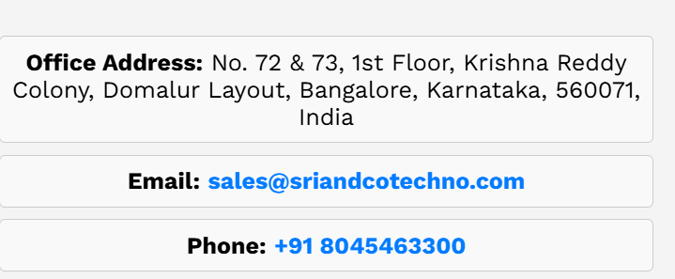

Below address is correct.

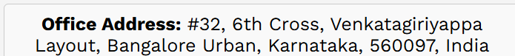

If its possible create one upload MSME document and import export code(IEC) upload box. (its Gona change every year that’s why).

FONT STYLE

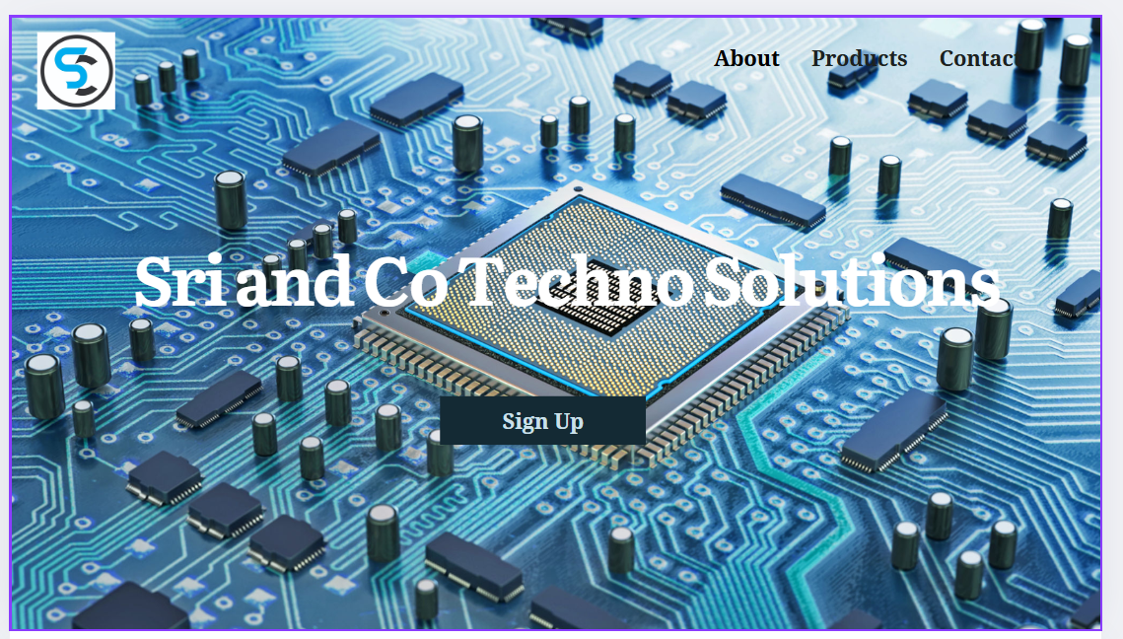

Figure : if its possible update the home page like this.

If we click on the logo it should go to home page.

After login

* It should appear a pop-up window like

Welcome, XYZ, to Sri & Co Techno Solutions!

* After creating a new account it should appear a welcome pop-up window.

Remove the prices as shown below in all image.



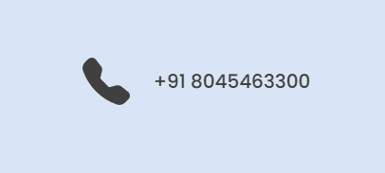

Please update the contact number

9916001569

9353961627

**Remove below sections**

Open-Source Software-Driven Hardware

Generic Consumer Electronics

Linkedin profile

[Sri and Co Techno Solutions | LinkedIn](https://www.linkedin.com/in/sri-and-co-techno-solutions-a814b6351/)

Please correct the Text alignment

Contact me for any doubt clarifications.

8317382845

Srikanth